TROUBLESHOOTING THEORY

1. Identify the problem
2. Establish a theory of probable cause
3. Test the theory to determine cause
4. Establish a plan of action to resolve the problem and implement the solution
5. Verify full system functionality and, if applicable, implement preventive measures
6. Document findings, actions, and outcome

WHAT IS A COMPUTER?

A computer will have a CPU, RAM, mass storage, and an operating system.

Laptops, mobile devices, and Internet of Things (IoT) devices are all computers.

CPU

Clock’s job is to tell the CPU to do something. It’s like the door bell in the stores. Light bulbs will be reset when clock works.

CPUs use pipelines to optimize the processing commands.

1 Hertz = 1 time per second (clock button can be pressed 1 time per second)

CPU speed means top speed.

Motherboards work at most 400 MHz. So there is an incompatibility between CPU and motherboard. We need some other device called clock multiplier. This is inside the CPU.

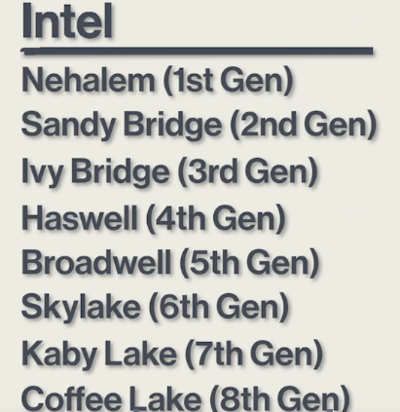PGA (Pin Grid Array) : There is a bunch of pins sticking out of the bottom of the CPU.

LGA (Land Grid Array) : Instead of having pins, it has little lands or little pads and the actual socket we drop it into has little pins to make the contact.

LGA 1151 (Intel) : Mainstream socket.

LGA 2066 (Intel) : Higher end socket.

Other sockets: AM4, TR4…

SDRAM (Synchronous DRAM)

Synchronous means that it’s synchronized to the same crystal (motherboard clock, sets the metronome for the CPU). Any given click of the clock, RAM do sth for us.

Have 2 notches.

Uses 168 pins.

DDR SDRAM : Double Data Rate SDRAM (name implies). For any one given click on the clock, this would give us two bits of information. Uses 184 pins. Have 1 notch.

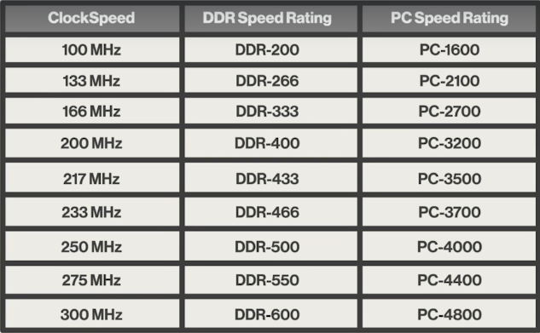

SPEED OF THE MOTHERBOARD DOUBLE OF THE CLOCK SPEED SAME SPEED WITH DDR BUT IN BITS

DDR2 : Doubled from DDR. Uses 240 pins. Have 1 notch. Place of the notch is different than normal DDR.

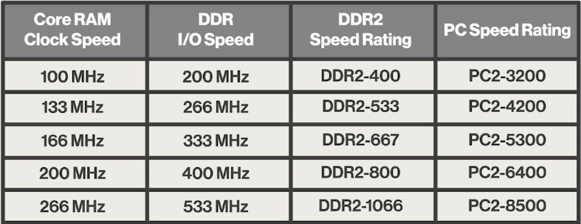

DDR3 : Doubled from DDR2. Uses 240 pins. Have 1 notch. Place of the notch is different.

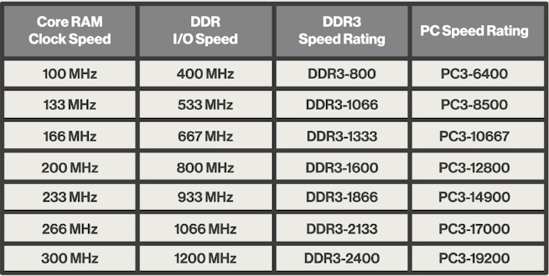

DDR4 : Uses 288 pins. Have 1 notch. Place of the notch is different.

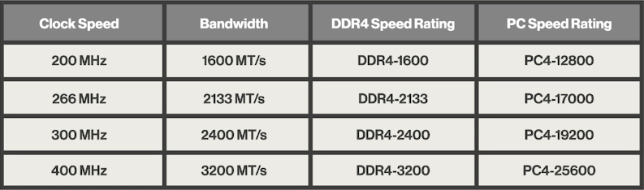

MT/s : Mega transfers per second. Means actual amount of data that’s being moved not necessarily just the clicks of the clock.

RAM chips are based on a square. So if you want to make bigger RAM, you have to double each side and this makes 4 times bigger capacity (256MB - 1 GB - 4 GB - 16 GB).

They make 2 GB - 8 GB RAM by doing double sided RAM. They are RAM modules that are organized into 4-bits.

Most of the RAMs are sold in pairs. The reason for that is because almost all motherboards use this concept called channels.

Dual-channel memory : I have to put two RAM sticks of the exact same size and hopefully speed. Dual channel memory provides simultaneous access to two RAM modules when reading or writing.

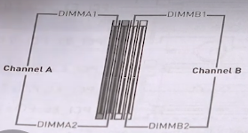

If you want a computer to run as fast as possible, you will put two sticks of RAM in it.

You have to put identical RAMs in same channel. Same speed, same capacity.

Putting same speed of RAM in different channel is good but not necessary. You can put different capacity RAMs in different channels.

If you put one RAM on one of the DIMMA, when you boot this thing up you’re gonna get a big error thing is gonna say “Running in single channel mode.” which is actually telling you that you’re not taking advantage of the power of this motherboard.

Most of RAMs have 8 black chips on them.

Parity/ECC (Error Correction Code) RAM : ECC RAM and Parity RAM can function with a failed memory chip. Have 1 extra chip known as parity chip to check for RAM errors. With parity I can have one chip of the other 8 be bad, with ECC I can have two of the other 8 be bad. Probably you see ECC RAMs in servers. They only for motherboards that support it.

SO-DIMM : Small outline. Used in laptops. Just a little bit smaller.

SPD (Serial Presence Detect) Chip : Little black chip on RAM that allows your system to query the ram chip and say what’s your capacity, what’s your speed, what’s your technology, who made you, what’s your model number. You need a tool to be able to query that chip.

Firmware : Means that it’s burned onto a chip as opposed to software which means that it’s copied onto some kind of magnetic media or electronic media.

In every motherboard, there is a little bit of programming built into the motherboard that’s designed to let you talk to the assumed hardware of the computer and it is BIOS. BIOS programs (services, setup, and POST) are code.

BIOS talks to the assumed hardware of the system.

There is BIOS chip on motherboards. There can be backup BIOS so 2 BIOS chips can be on the same motherboard.

POST (Power-On-Self-Test) : Built into BIOS chip.

When you turn on the computer, CPU talks to the BIOS and run a piece of BIOS known as the POST.

POST is very simple program. It broadcasts out throughout the motherboard it says if you can hear me check yourself out.

If motherboard is OK, it response to CPU “I am great.”.

If sth is wrong your computer has to report to you.

If video is not working then beep codes say us sth wrong.

For example “I don’t have a video card”: _..

“I can’t find any RAM”: __.

POST Cards : There are 2 hexadecimal characters on it. These are the POST itself as the system boots up. On motherboard book, there are pages that show you what these hexadecimal numbers mean.

Once the operating system kicks in, anything that you read on that post code it's gibberish it doesn't mean anything.

Settings that you actually make to the BIOS, such as date and time, fan speed,retained in the CMOS chip.

Today we separate these CMOS chips. Today we have Single Flash ROM Chips (Flash Memory). We can reprogram it if we want to update that built in BIOS. The entire contents of the chip must be overwritten when flashing the chip. BIOS programs and UEFI programs are held in the system ROM chip. Flashing the ROM updates the firmware on flash chip.

System Setup is an interface that we get to on our computers and we are gonna use our mouse and keyboards and we are gonna make changes to the changeable part of our BIOS.

UEFI (Unified Extensible Firmware Interface) BIOS : Supplanted BIOS. Bigger, better, cooler. Secure Boot is feature in UEFI that stops any digitally unsigned drivers from loading and helps to stop malicious software, such as rootkits.

RTC (Real-time Clock) : In a Windows network for example all of the computers in the network need to be very closely and I mean within milliseconds synchronize to the same time or they won't even boot up. To do this RTC still exists. RTC is in the CMOS chip. It must work even computer is turned off so we need electricity. CMOS battery provides this electricity. CR2032 provides power to the RTC and CMOS chip.

Flashing the BIOS is for fixing bugs and adding features to the contents of the BIOS chip.

Motherboard Types

ATX : 12 x 9.6 inches. Biggest common form factor.

Micro ATX : 9.6 x 9.6 inches.

Mini ATX : Smallest common form factor. There are smaller ones but you’re not gonna be able to put regular CPU, RAM, etc.

ITX : Larger version of mini ATX.

Motherboards and cases follow standardized form factors.

Chips on motherboard controls serial ports, hard drives, sound card, mouse, etc.

Special purpose chip : Chipset. Chipset is dedicated chips that took on all of the different jobs mentioned one line above.

Northbridge and Southbridge are the name of different chipsets on motherboard.

Northbridge acted as the interface to the CPU. It has memory controller built into it. It handled high speed expansions buses so the North Bridge was always doing the fast stuff.

Southbridge was the interconnection to the slower stuff.

Today’s CPUs take over all of the northbridge functions. Therefore today’s chipsets are really just a southbridge.

It's the chipsets that define:

* how many sticks of RAM you can support,
* how many video cards you can put into your system,
* how fast of RAM you can have,
* how many USB ports you can support and what speed are these USB ports,
* how many hard drives you can install.

Chipset’s job is control data flow between the CPU, peripherals, bus slots, and memory.

So all of the different parts of the computer communicate with the CPU through the chipset.

SATA cables are for harddrives.

Power supplies provide 12 volt, 5 volt and 3.3 volts to the systems but then they have to to take those three voltages and break them down into literally hundreds of different voltages. Your typical CPU today has a minimum of five different voltage inputs of different voltages. So any motherboard today is going to have tons of voltage regulator modules and capacitors which are adjusted all these voltages.

PCIe Expansion Slot : You can put your video card, etc. It’s type of expansion bus that basically uses serial connections. Early version is PCI. PCI was using 32 wires parallel connections.

Single Lane PCI Socket (x) : Smaller.

4 Lane PCIe Socket (x4) : A little bigger.

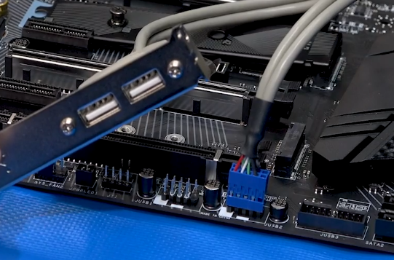

Cable and USB slots device is dongle.

You can connect dongles to the motherboard with using these connection pins.

Power supplies are step-down transformer that convert AC power into DC power.

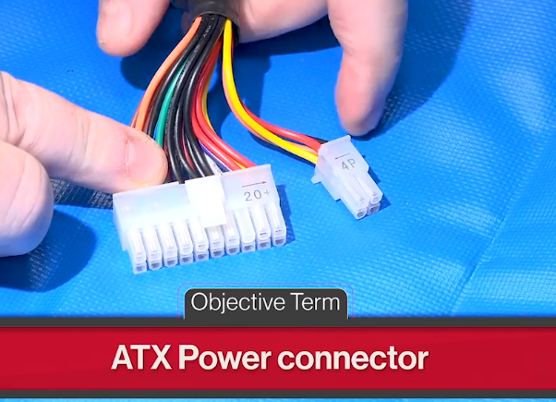

Yellow : 12 V

Red : 5 V

Orange : 3.3 V

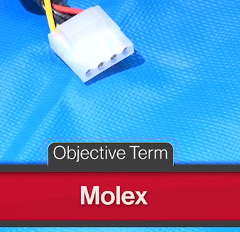

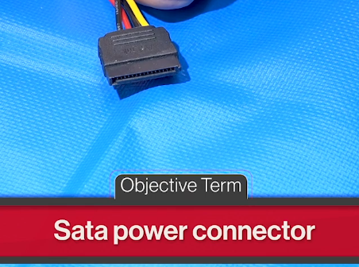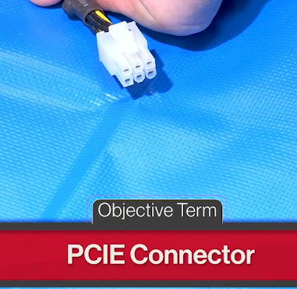

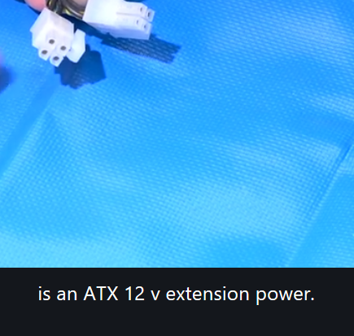

All storage devices got some kind of minimum storage space - atoms. They all divided into the smallest amount of storage they can handle.

STORAGE DEVICES AND THEIR ATOMS

HDD : Sector (512 bytes - 4096 bytes)

SSD : Blocks (1000 bytes)

Optical Media : Tracks (1000 bytes)

Which ties sectors, blocks, tracks : LBA (Logical Block Addressing)

LBA is some controller circuitry it's a little bit of hardware and a little with a little help of software that acts as an interface between your operating system and all your different storage devices.

If you're operating system needs to save a big file what it's going to do is it's going to go up to the counter of LBA and it's going to say “I want to save this big file” and the LBA person is then going to go ahead and take it and he's going to allocate blocks.

It's your LBA that actually allocates however many blocks are necessary to save that big file.

OS sees mass storage as a string of logical block addresses.

LBA is the device driver for all of the different types of storage on our system. When you install hard drives when you install optical media when you install an SSD unless extremely rare cases you don't have to put in a device driver along with it because LBA is inherent to all operating systems all mass storage devices.

|  |  |
| --- | --- |
| 1 000 | KILO |
| 1 000 000 | MEGA |
| 1 000 000 000 | GIGA |
| 1 000 000 000 000 | TERA |
| 1 000 000 000 000 000 | PETA |
| 1 000 000 000 000 000 000 | EXA |

IEC VALUES

|  |  |
| --- | --- |
| 2^10 | Kibi |
| 2^20 | Mebi |
| 2^30 | Gibi |
| 2^40 | Tebi |
| 2^50 | Pebi |
| 2^60 | Exbi |

Kilo : 1 000 Kibi : 1 024

Mega : 1 000 000 Mebi : 1 048 576

Giga : 1 000 000 000 Gibi : 1 073 741 824

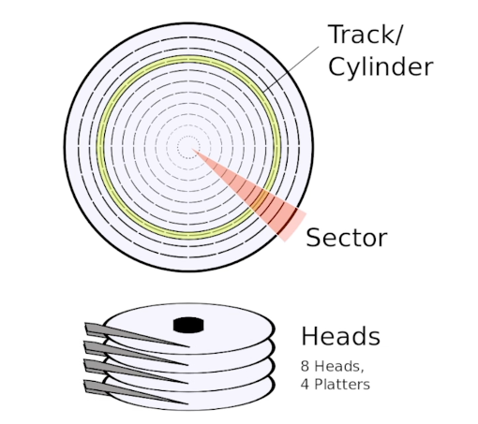

We need to speak LBA’s language.

Advanced Technology Attachment (ATA) : Protocol that HDDs speak.

Parallel ATA (PATA) : Old.

Serial ATA (SATA) : New.

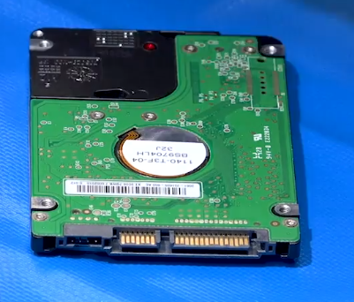

Yellow connectors are SATA connectors. Big one (right) is the power connector, small one (left) is the data connector.

eSATA connector : Just a SATA connection but it’s designed to be used externally.

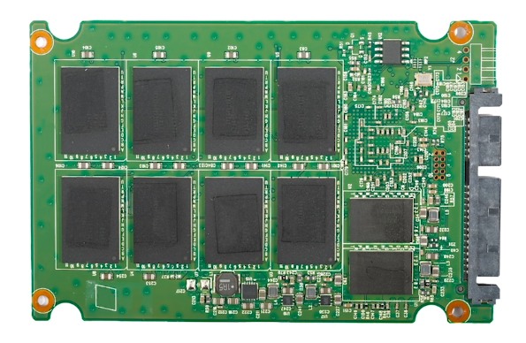

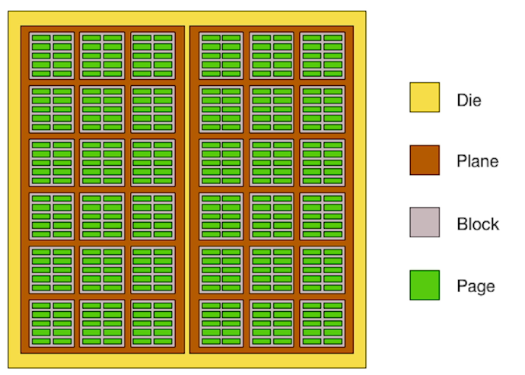

“Inside one of the chip”

Each Block contains a specified number of Pages (32 to 256), which in turn contain a specified amount of data (2 to 8KB).

SSDs are using SATA connection too.

SATA uses a serial data transfer protocol. Data is transferred one bit at a time from the drive to the computer and one bit at a time from the computer to the drive.

Traditional SATA interface runs at a max around 6 gigabits per second.

NVMe (Non-Volatile Memory Express) : There is NVMe protocol on M.2 SSDs instead of SATA.

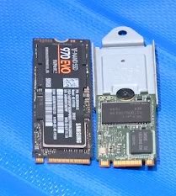M.2 SSDs

Right one is SATA.

Left one is NVMe.

NVMe is much faster.

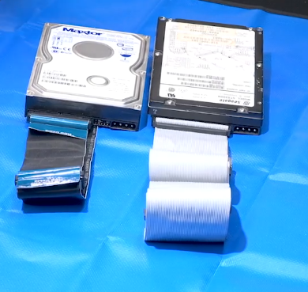

Left one is Parallel ATA (PATA). You can only put 2-4 hard drives in a system.

Right one is SCSI (Small Computer System Interface). You can put 7-15 drives in a system. You can see them in server systems.

These systems are gone. The ATA language is the same but instead of going through a bunch of parallel cables it goes through a serial connection.

The old parallel SCSI is long gone, but the SCSI language lives on in serial SCSI versions.

When we talk about SCSI with mass storage, we talk about a very specific type of drive called Serial Attached SCSI (SAS).

SAS Connector

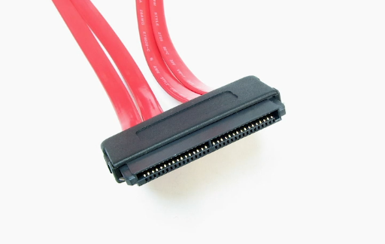

SCSI is not very popular. We see SCSI in a lot of crazy places in fact. Another place you're going to see SCSI is ISCSI. ISCSI simply means that you have SCSI devices that are connected to your computer via ethernet cable. So the only place you're going to be seen SCSI anymore is going to be in server situations.

When you boot up your computer, first thing it does is POST. But once it does a power on self test it's going to be looking for a storage device with an installed operating system from which to boot.

Let’s say you have 2 HDD, 2 SSD, 1 optical media, 1 thumb drive so a total of 6 mass storage devices. The challenge we run into is which one do I want to boot from first. When you have a lot of different types of storage devices you have to define the boot order and the place that we define that boot order is in our system setup.

Redundant Array of Inexpensive Disks (RAID) : Type of drive organization.

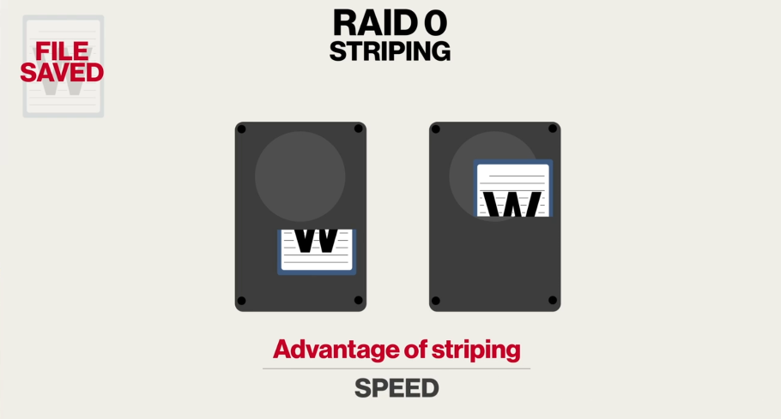

Downside of RAID 0 is that you don’t have any data safety at all. If either one of these drives die you're going to lose everything.

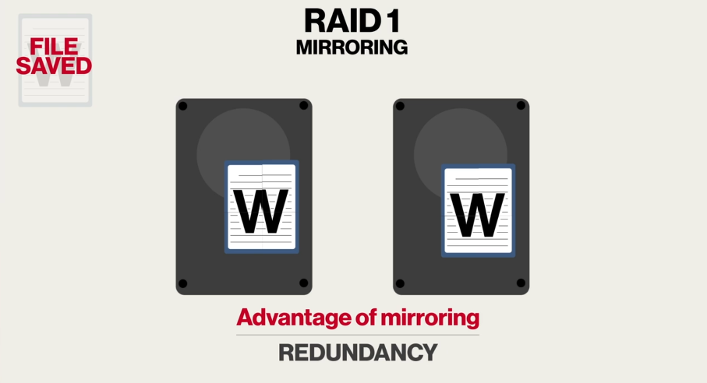

You can do it by 4 too.

RAID 1 provides safety. Downside of RAID 1 is slowness because you are writing twice.

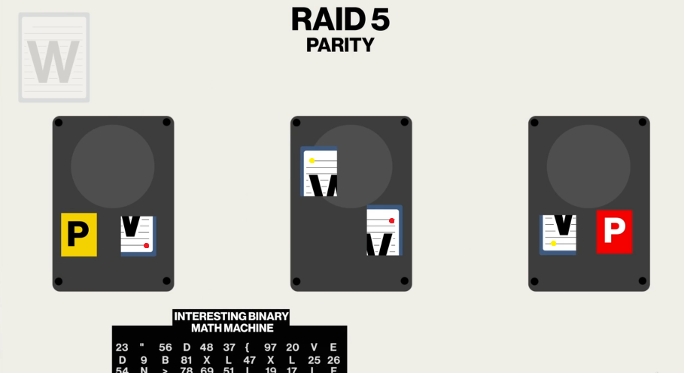

Minimum 3 drives.

We do some operations to 2 pieces of the document and create a parity (P).

Size of parity is the same with other 2 pieces.

If one of the piece is lost, we can recreate it with do operations on parity and the existing one.

With RAID 5, you get redundancy of your data and very good speed.

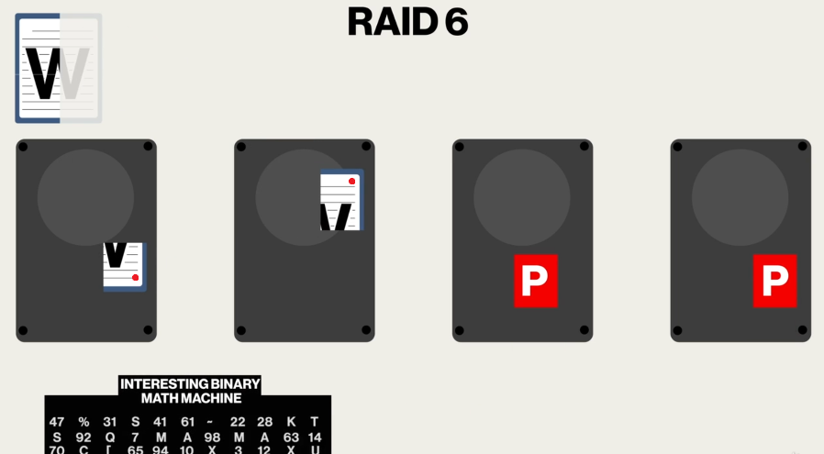

Minimum 4 drives. We create 2 parities.

RAID 6 is more popular because we can lost up to 2 drives without losing any data.

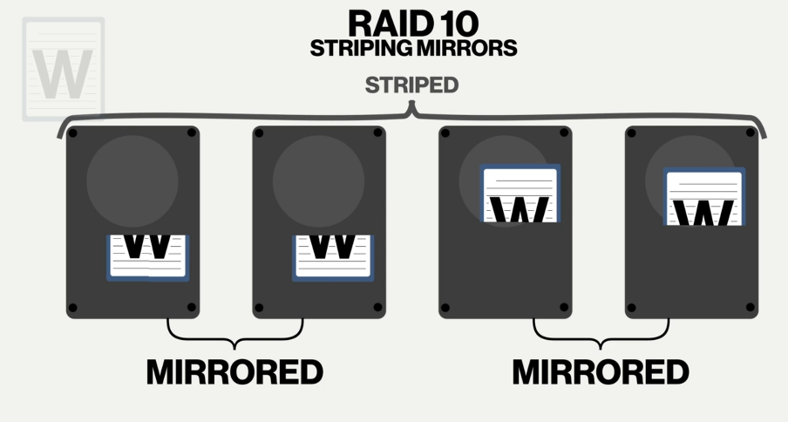

Minimum 4 drives. Technically you have to have two pairs.

Nice part is I can lose one of the mirrored pairs on each side and I'm still in good shape.

The downside is if I lose one complete mirrored pair I'm in trouble because we've lost half of the stripe.

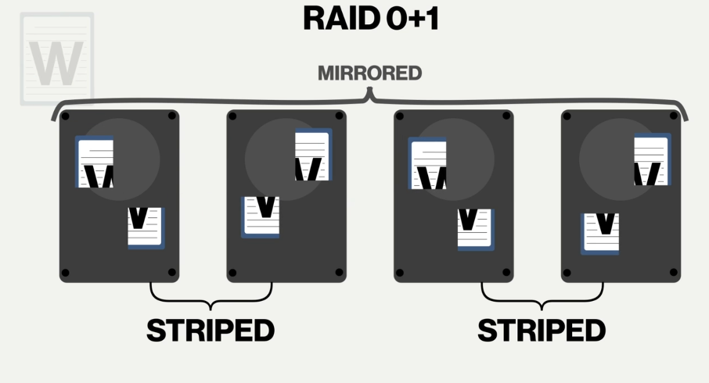

Minimum 4 drives. Technically you have to have two pairs.

We can lose one complete striped pair on either side and we're OK.

The downside would be as if we lost one on each side, we wouldn't be able to rebuild the mirror and we'd be in trouble.

You can do RAID by dedicated controllers that are built into your motherboards or a card you can snap in and we hook our drives to that controller and we go “OK we want you to be RAID 1 or RAID 5 or whatever it might be.”.

Another option is most operating systems support some levels of RAID built in.

AHCI mode : Basically means we can't do any of this groovy RAID stuff.

Hot spare / Swappable drive : In RAID system if one drive dies, you can replace it. With certain hardware RAIDs, you can have that drive sitting there ready to go. It’s like backups in football. So you’ve got another a hot spare ready to go.

Hot swappable : I don’t have to shut my system down to yank out a hard drive and plug it back in.

Hardware RAID has its own BIOS that comes with a special system setup to configure the RAID array.

The completed array looks like a single drive to the OS.

S.M.A.R.T Technology : Built into all hard drives and with the right tools we can actually query drive and get a relative idea as to its health. S.M.A.R.T is the only real tool we have. If a drive is starting to act up, you can run a S.M.A.R.T detector.

CD (Compact Disc) : Originally designed to play music. Capacity is measured by minutes.

CD-ROM (Compact Disc - Read Only Memory) : Allow us to store data. So we had to come up with a file system and that file system was based on a standard called ISO-9660 (CD File System - CDFS) which allow us to take CD, put it into a CD drive and then within OS we can actually see the folders and files as they were originally mastered.

CD-R (CD-Recordable) : We can put whatever we wanted. You can’t erase it.

CD-RW (CD-Rewritable) : We can put whatever we wanted. You can erase it.

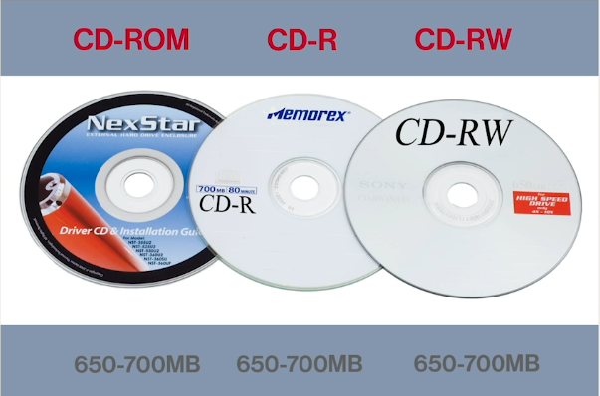

DVD (Digital Video Disc - Digital Versatile Disc) : Originally designed to play movies.

DVD-ROM (DVD-Read Only Memory : Using DVD to hold data.

DVDs come with Dual Layer (DL) format. You had two layers and you had different lasers that would hit different layers.

DVDs also come with Double Sided (DS) format. These DVD’s have silver on both sides.

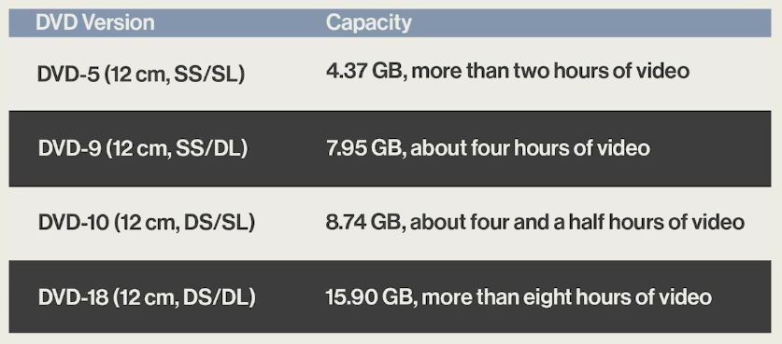

DVD+R : Burn once DVD.

DVD-R

DVD+RW

DVD-RW

Today any optical media device can read and write any of these different formats.

Blu-Ray Disc : Designed for high definition movies.

Blu-Ray ROM

Blu-Ray also has double sided and double layer.

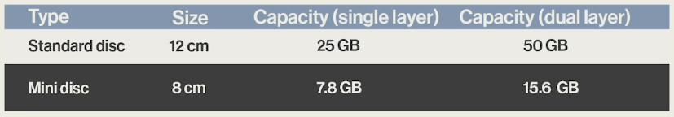

BD-RE (Blue-ray Disc Recordable Erasable) : Rewritable

ALL OPTICAL MEDIA COMES IN READ-ONLY MEMORY (ROM), WRITE-ONCE (R), AND WRITE-MANY (RW/RE) VERSIONS.

|  |  |
| --- | --- |
| CD | 650 - 700 MB |
| DVD | 4.37 - 15.9 GB |
| Blu-Ray Discs | 25 - 50 GB |

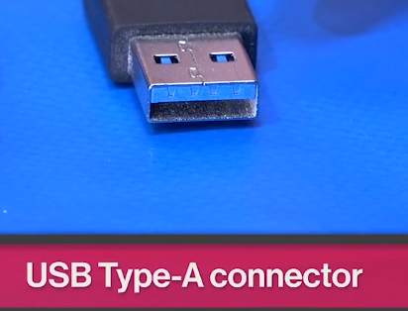USB (Universal Serial Bus)

USB 1.0 : 1.5 Mbps

USB 1.1 : 1.5 - 12 Mbps (Keyboard, mouse…)

USB 2.0 : 480 Mbps

USB 3.0 : 5 Gbps. This one has some issues.

USB 3.1 Gen 1 : 5 Gbps

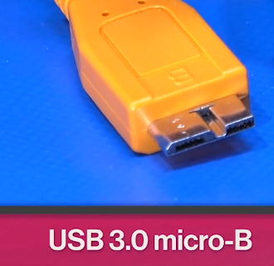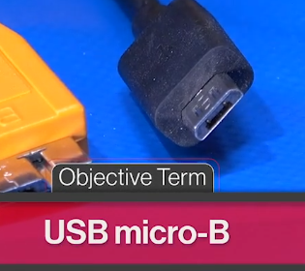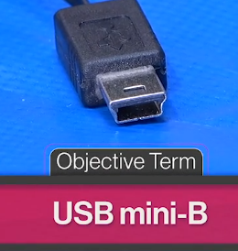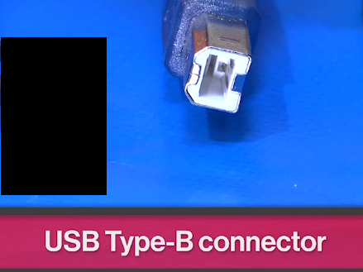USB 3.1 Gen 2 : 10 Gbps

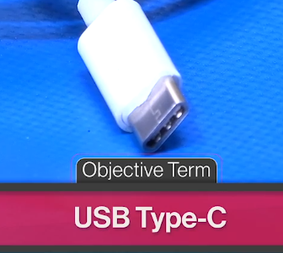

Type C capable of handling extremely high speed data.

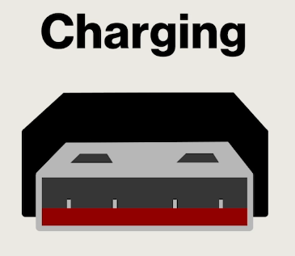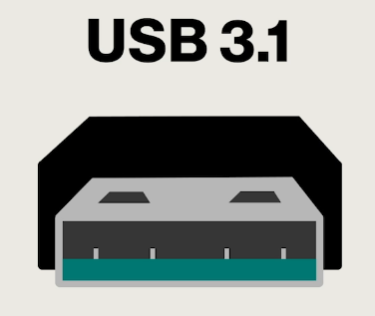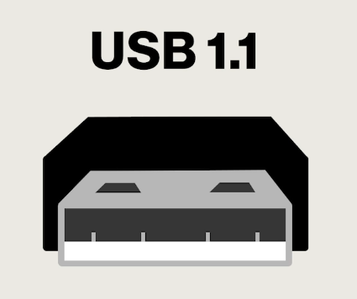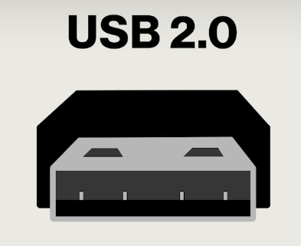 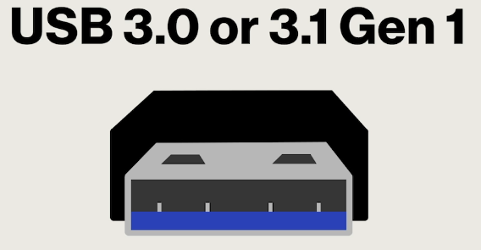

Charging ports can actually be orange, yellow or red.

USB is backward compatible. If you have a USB 3.0 one thumb drive and you plug it into a USB 2.0 port, it will work but it's only got to run at the speed of that port.

When I plug USB in, I'm plugging it in to for example a system that has a motherboard with a built in USB controller. It’s like a network from which we connect all these different USB devices and built in to the motherboard itself is this controller that simply makes all this other stuff work.

Controller built into my motherboard is controlling and sending commands downstream.

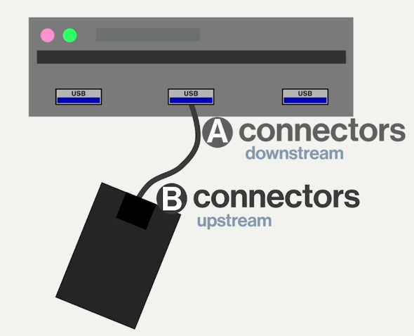

USB Type-A connectors plug into downstream USB ports,

USB Type-B connectors plug into upstream USB ports.

With classic USB we always have an A and a B connector.

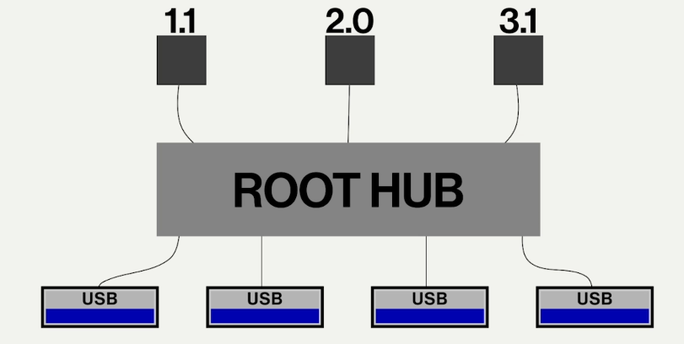

No matter where you plug in you can always connect to the three dot one controller.

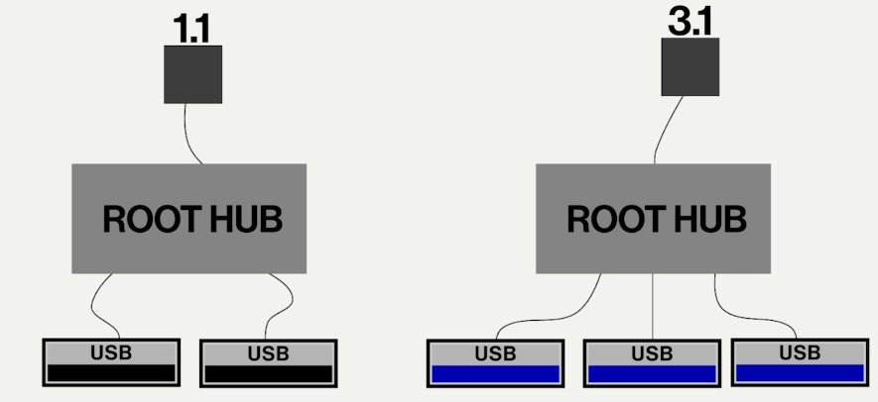

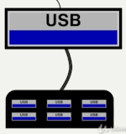

(Above black squares are USB controllers.)

USB allows you to plug in up to 127 devices and you do that via USB hubs. ----->

Whatever device is connected to the end of the USB is going to need a device driver (keyboard, camera…).

First installed a device driver for the thing then plug it in and then it will work fine.

In today's especially Windows 10 world I pretty much just plug things in. Windows has tens of thousands different device drivers built into the operating system itself and on the rare occasion when it can't find a device driver it will go online automatically download it for you and install it.

Both of Windows 8 and 10 they automatically grab stuff and they have a huge cache of drivers.

If there is no device driver for some device that you plug in with USB, you should install the device drivers you need with thumb drive etc.

HID (Human Interface Device) : HID device drivers are just like core device drivers always to make sure that mice and keyboards work. They are base drivers that get the core stuff working. If your mouse, keyboard, etc. has extra features, you're gonna have to get a device driver that supports the extra features of that HID device to get full functionality.

USB lock : Some kind of software that's designed to watch over your USB ports and not only will it prevent people from being able to use the USB port but it can also perform reporting. Also certain USB thumb drives for example can work.

Thunderbolt : Kind of a combination of the PCIe and a display port all combined into one. It will do anything you want kind of port. It will drive monitors you can charge with it you can do data transfer you can do anything you want with a thunderbolt connection. Uses a mini DisplayPort or a USB C connector.

Thunderbolt 1 : 10 Gbps (x2 channels)

Thunderbolt 2 : 20 Gbps

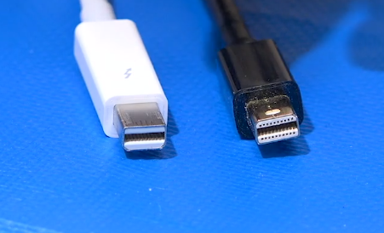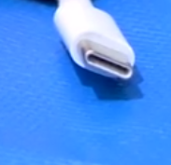Thunderbolt 3 : 40 Gbps ---> like USB C

Thunderbolt is also used as mini display ports.

Lightning : Exclusive to Apple products. Used for charging devices, data transfer…

5 Gbps

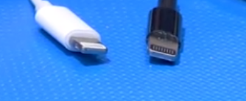

If you’re running Mac OS, you’re probably gonna be using a thunderbolt connector.

if you're running IOS, you're gonna be using a lightning connector.

PS/2 mouse ports are green. PS/2 keyboard ports are purple.

The only downside to P.S.2 is that you can't plug it in on the fly you're gonna have to shut your system down plug it in, shut your system unplug it.

KVM Switch (for keyboard, video, and mouse) : Designed to allow one set of input devices and monitor share between multiple physical computers.

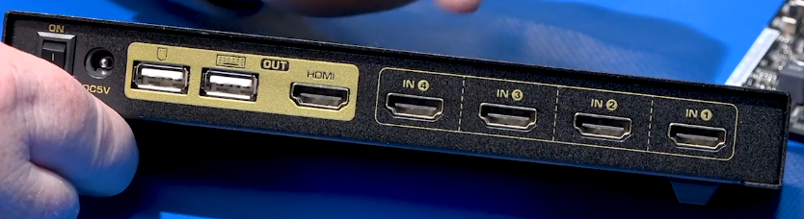

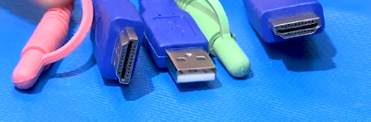Right HDMI goes to the KVM.

USB is for mouse and keyboard.

Left HDMI is gonna handle the video coming from the computer.

Pink and green are for sound.

One end of the cable is rightmost HDMI, other parts are in other end.

You just have to press to button in front of the KVM to change between computers.

2.1 Speaker System : 2 regular speakers and 1 big subwoofer (for low frequency sound).

ANALOG CONNECTORS

Blue cable input : Auxiliary line in. If you have like you're recording from something you would go from that device straight into here.

Green cable input : For front 2 stereo speakers. (1-2)

Pink cable input : For microphone.

Silver cable input : If you have 2 more speakers (side speakers). (3-4)

**Black cable input** : Rear speakers. (5-6)

Orange cable input : For a subwoofer and a center channel.

Center channel is a big speaker that sits right underneath the monitor. Usually for dialogue and stuff like that.

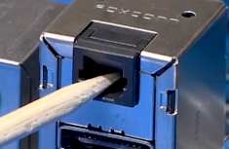This like a door connector is an optical connector that's used exclusively for audio and it’s called as S/PDIF (Sony/Philips Digital Interface).

You'll see this in a lot of situations where you want to plug your computer into a receiver system and you can make a direct plug in there and that'll then propagate out to all your speakers.

S/PDIF provides digital audio output.

Many devices like webcams or headsets include speakers.

Chips on cards store credentials that help authenticate this card to whatever they might be doing typing in pass codes or buying gas whatever it might be. These are smart cards.

Smart Card readers are used to read cards.

Magnetic Reader : You swipe your card.

Flash Memory Reader : Read many types of flash memory. SD cards are very popular flash memory.

Flatbed Scanner : Scans paper documents one page at a time.

ADF ( Automatic Documant Feeder) : You can put bunch of documents and it will scan them.

Barcode/QR Code Scanners : Read printed coded labels.

Expansion cards may be sound cards, network interface cards, USB expansion cards, eSATA cards, etc.

For example you put a USB expansion card on PCIe slot. This expansion card usually comes with an optical media. You can find device drivers (If Windows doesn’t see the expansion card, you must install them) and may be applications.

Difference between thin client and thick client is: thin client rarely counts on its own internal storage to do anything. So the big clue here is going to be network connectivity.

Thin client doesn't use its own storage to keep its applications and such.

Network attached storage or NAS device is a box that sits on your network. This is usually what we call a headless system. Once it's up and running usually don't have a keyboard or a mouse or a monitor with it it just sits there and it does one job really well. It’s job is file sharing.

Pixel (Picture Element) : Consists of 3 individual pieces that emit red green and blue light.

LCD (Liquid Crystal Display) : Each one of these individual elements. The colors are just film put on top of them. If we put electricity onto an element, light can go through it. If we take electricity away it becomes completely opaque and light cannot go through it. We can even adjust the amount of light so they kind of dim or brighten and that allows us to have different colors of light. This is where the famous RGB values of light come from. LCD contains liquid crystal that changes opacity.

The only thing that happens is LCD can either let light pass or block light. So all LCD monitors have to have some kind of backlighting to them.

On the first generation LCD we used a cold cathode fluorescent lamp (CCFL). Entire panel is backlit by fluorescent tubes. Fluorescent lights need AC power. So CCFL screens need inverters (take the DC power that was just converted from AC and turns it back into AC to run the CCFLs).

Nowadays entire panel is backlit by light emitting diodes (LEDs). A lot thinner.

If I want to generate the color green what I'm going to be doing is I'm going to make sure that there's absolutely no charge on the blue and that there's no charge on the red. So that's going to block light and then I'm going to put a big charge on the green which will clear it and my backlight will come right through and it'll be nice and pretty and green.

Resolution : Pixel numbers.

Brightness : When we talk about brightness we use a value called Nit (nt). Nit is a measure of light. 200-500 nits for a good LCD panel.

Response Time : Panel be able to reset itself so that we have that persistence of vision which allows us to detect motion. Response time is how long does it take for one of these pixels to go from all black to all white and back to black again.

Panel response times run from about 1 ms - 4 ms.

OLED (Organic LED) : You can make really thin monitors with it. Doesn’t use backlight, pixels make their own light.

Digital Light Processing (DLP) : Uses grid of tiny mirrors that shine through a color wheel to create an image.

You have a light source that is going through a color wheel that's spinning out RGB colored. So those lights turning on and off very quickly and it's hitting this big grid of mirrors and then reflects out and you make all the different colors. DLP is quite popular with projectors.

In older days, in order to make something appear on a screen, you had to use some kind of RAM that kept track of what is in every single pixel electronically and then you would push that out to the monitor itself. That works and it's known as frame buffering.

GPU (Graphic Processing Unit - Video Card)

In today’s world, we have very smart processors : GPU. GPU handles all individual addressing.

Instead of talking to our video card and saying “this pixel is red this pixel is blue this pixel is blue…” million times, what we do instead is we go to our GPU and say “put a circle right here” or “here's an icon that I'm using a lot. Keep that in another part of your memory (because GPUs also have their own memory -RAM chips-.)”.

RAM chips on video card do nothing more than actually store what’s on the monitor at any given moment.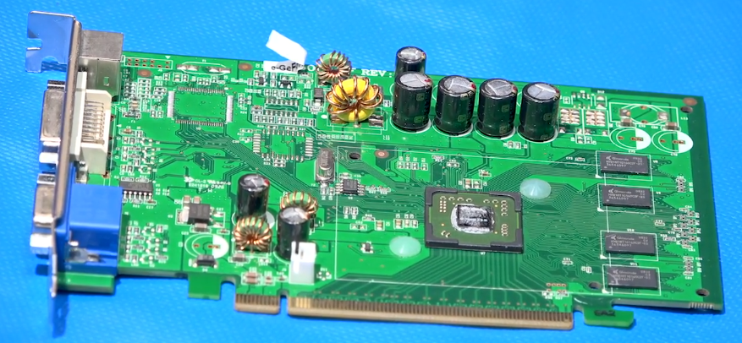

What will take place is a cycle many times per second (a minimum of 60 times a second), we have a little scanner and the thing is just scanning back and forth and every time it has one of these cycles it shoots new data out to the monitor and the monitor resets all the pixels for over to the new image.

So you might be just moving to a icon across your desktop but your computer is setting that image up a minimum of 60 times a second.

Some CPUs have built in CPU. ---> CPU + GPU = APU

At video card, there might be 8 GB of RAM. That's not only to resolve the screen but a lot of times it'll be resolving the next screen getting it ready to go.

Connectors (Video Card - Monitor)

VGA ( Video Graphics Array) : Uses analog signal. If you use VGA with LCD, monitor have to convert analog signal into digital signal 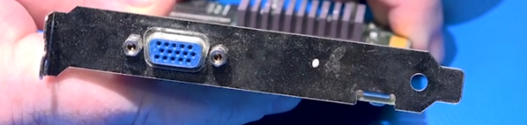

DVA (Digital Visual Interface) : Uses digital signal.

Four holes at the right is for analog signal, they are basically for VGA. If you have old VGA monitor, you can still use this video cards. But you need to have an converter (one end for DVA pin, other end is VGA above. It’s DVA to VGA connector). This white ones are DVI-I (do both Digital and Analog).

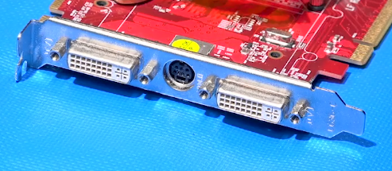

This is (one at the above) DVI-D (digital only).

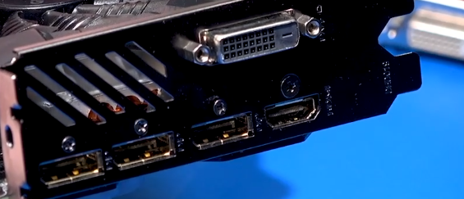

DVI comes out in 2 versions :

* Single-link DVI
* Dual-link DVI : You could take one DVI connector in your card and run 2 monitors. However over time monitor resolutions kept getting bigger and bigger and we see Dual-link now designed to handle large high resolution monitors to show you all of them.

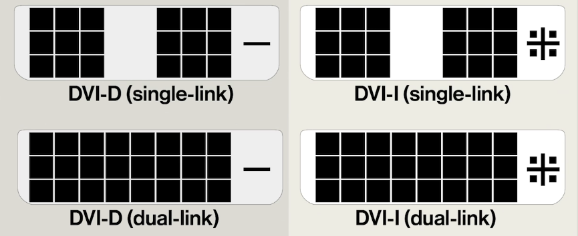

Digital Rights Management (DRM)

HDMI (High Definition Multimedia Interface) : Supports DRM.

DisplayPort :

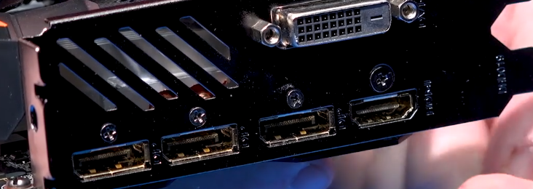

Left 3 is DisplayPorts. Right one is HDMI.

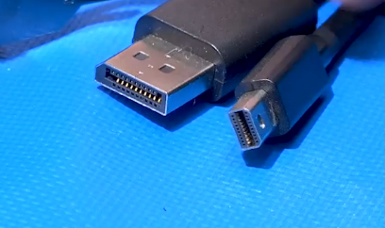DisplayPort - Mini DisplayPort

Riser card : Plugs into your main expansion bus and gives you an extra slot.

2 Projector technologies : DLP and LCD

Projectors have resolutions and aspect ratios just like monitors.

Lumens : Define the brightness of the projector. More lumens mean more brightness.

For dark places around 1200 lumens are OK.

For bright places around 2500 lumens are OK.

In LED projectors, bulbs last forever.

Throw : You get smaller image if you get close to the screen and vice versa. All projectors are gonna have a minimum and a maximum recommended throw distance.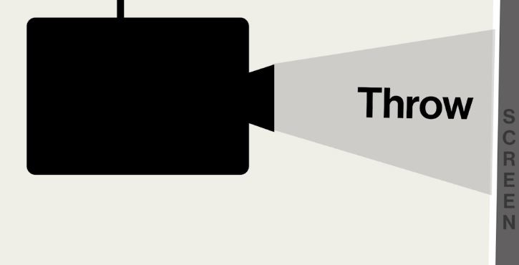

When you fire projector out on the wall the first time you're gonna be dealing with a lot of lenses and you get some fairly interesting shapes. You need to make adjust.

Pincushion shape Keystone shape

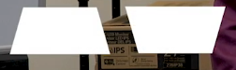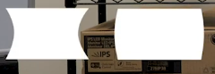

Skew shape

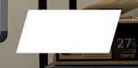

Artifacts : Artifacts are where pieces of stuff show up on the screen that look like they may have belonged there earlier but they don't belong there anymore. The first thing you're going to be taking a look at with artifacts is their video ram itself.

DIM image : DIM image is means that somebody who's making light isn't making enough light. This was a big problem on older CCFL LCD panels. DIM images are caused by a low brightness setting, failing CCFL, or failing inverter.

Incorrect color patterns may be caused by loose or failing connectors.

Dead pixels and burn-in cannot be fixed.

VIRTUALIZATION

A virtual machine is a completely self-contained computer that is running within a host operating system.

Virtualization means I'm going to take some of the real physical hardware you have and allocate some of these to a separate internal system. This system will use a little bit of your CPU, a little bit of your RAM a little bit of your hard drive. You can configure this stuff but it cannot do anything that you don't already have. For example in my computer I couldn't run an Nintendo 64 virtual machine.

Emulation is when you pretend to have hardware that you don't have. Nintendo 64 does not run on an Intel type platform. So if I wanted to do something like that then I would have to have a emulator.

For virtualization you have to have a CPU that support virtualization. You can enable it from the system setup.

Hypervisor is the actual host that runs the virtual machines. It supports multiple VMs. There are two kinds of hypervisor is out there :

1. Type 1 hypervisor runs directly on top of the hardware as an OS. Type 1 hypervisor installs OS just like any other OS onto your system. Type 1 has nothing between it and the actual hardware itself. We then begin to create virtual machines that run on top of that hypervisor itself.
2. Type 2 hypervisor runs as an app in an OS. Type 2 hypervisor going to have some kind of OS has already installed. Then we install the hypervisor which installs like any application. We don't install it like an OS and then we run the virtual machines on top of that.

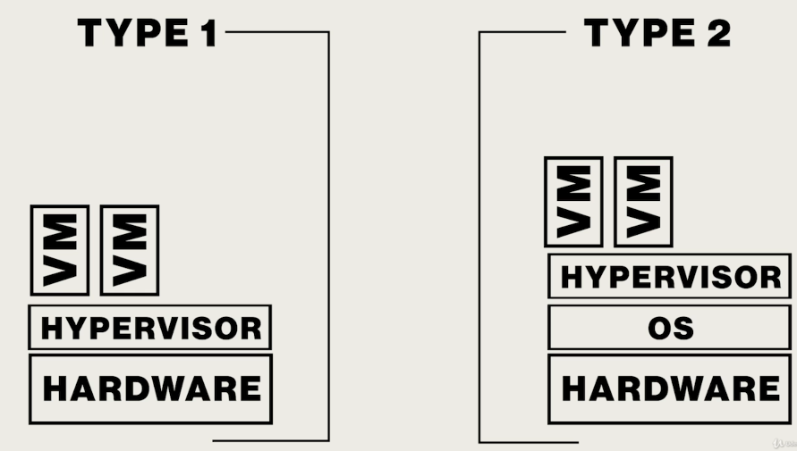

Oracle VM Virtualbox is Type 2 hypervisor. Virtual machine itself doesn't see the actual host OS. The hypervisor is between virtual machine and the host OS and as far as it's concerned, that's all there is in the world. When you turn off a virtual machine, it just turns into a file. The entire virtual hard drive just turns into a file that sits on your regular hard drive and you can fire it up anytime you want.

In terms of security and recovery virtual machines are absolutely incredible.

Almost all web sites today are VMs.

By putting the operating system between the hypervisor and the hardware we don't get a lot of efficiencies.

We can create virtual networks with VMs. I have a virtual network card built into the system. I can create virtual switches where I can make 4 computers and connect just those 4 computers together in their own little network. I can make a virtual router and that router can do NAT and I can set up a virtual router with NAT and then those 4 computers can all be connected to the Internet.

Fixed space is faster but dynamically allocating saves on harddrive space.

With bridged adapter, your VM will directly connect to a real network card on your system.

When we bridge the virtual machine, what we're doing is we're in essence installing a virtual network card onto the exact same network and it goes through your real computer. If your computer is getting network ID of 192.168.4.x from a DHCP server, VM will too. So you literally have your virtual machine joining the same network as your host computer.

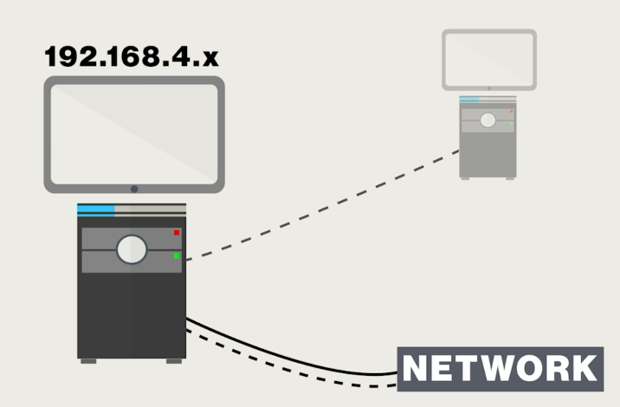

With NAT, what you're actually doing is you're creating a virtual router. This router treats your individual physical host computer as your ISP. It only allows you to connect one computer to this virtualize network ID. Virtualized router also has DHCP server that assign IP.

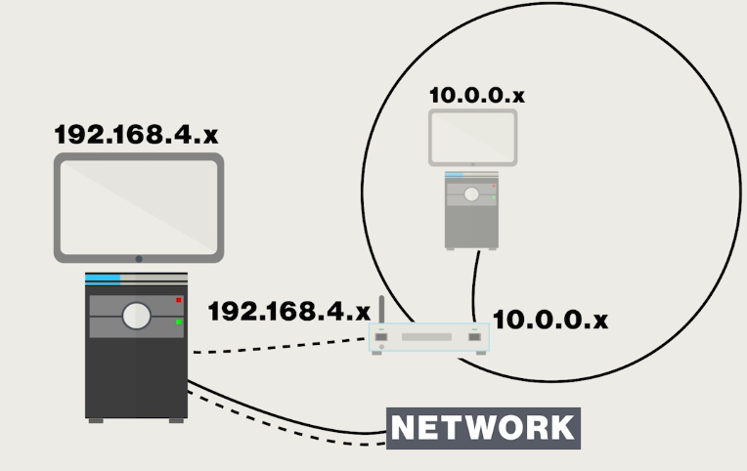

With NAT network, you can have for example 3 virtual machines on their own network going through their own little virtual router (You created the NATnetwork and Tempo on virtualbox.).

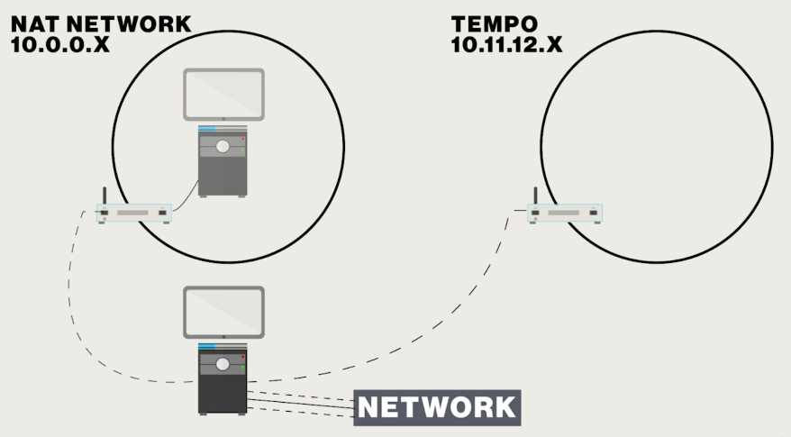

With internal network, you're going to have a bunch of computers on an internal network but there will be no router out to the internet through your own computer. It's just going to be its own little internal network.

With host only adapter, it's going to be directly connected to the particular host network card and that's something you probably want to avoid using.

With generic driver, it's going to pretend to be a different kind of network card. Generic drivers are often used if you've got some really old operating system you're trying to get it to run in a virtual machine and it doesn't know about modern network cards. You can actually go in and have it pretend to be a different kind of network card that's actually emulation.

The Cloud means I don't know physically where computers located but I can access it by its IP address.

Every time you open up a web browser and go to Google you are doing a cloud function because there is a web server somewhere out the universe, you don't know where it is but it's working for you. You can manipulete them, administer them using remote tools. You have its IP address you control it's URL that type of thing.

Cloud computing moves the VMs “out there”, but accessible via IP.

IaaS (Infrastructure as a Service) moves network tasks such as firewalls into the cloud.

PaaS (Platform as a Service) moves the machines iinto the Cloud so you can concentrate on apps.

SaaS (Software as a Service) moves apps to the Cloud such as google docs.

Private clouds are owned and used only by a single organization.

Public clouds are privately owned but are available for public use.

Hybrid clouds have both private and public aspects.

Community clouds are owned by multiple organizations for their own private use.

Cloud storage enables access to synchronized saved files from any device.

Mobile devices have single, sealed unit.

Hotspot : Lots of people can get on the Internet through you.

Tethering : Only one machine at a time can get on the Internet through you.

There are 2 kinds of phones :

* CDMA (Code Division Multiple Access) Phones : Are not be using with a SIM card. There is no hardware.
* GSM (Global System for Mobile Communications) Phones : Be using with a SIM card.

IMSI (International Mobile Subscriber Identity) : It gives a lot of personal information. Defines critical SIM information. Built into the SIM.

IMEI (International Mobile Equipment Identity) : Defines the phone. You need to connect IMSI to IMEI. This activates the phone.

POP 3 and IMAP are for incoming, SMTP is for outgoing email.

POP 3 encrypted port : 995

IMAP encrypted port : 993

SMTP encrypted port : 465 or 587

What you are getting out of these ports is point-to-point encryption (P2PE).

S/MIME (Secure/Multipurpose Internet Mail Extensions) : MIME basically takes a binary file and takes every eight bits and turns it into what's known as an ASCII code. In essence it turns all of your data into ghibligoblets of text which can then be read by the receiving thing and then turn it back into your video or picture or whatever it might be.